DBMS

1. <https://www.sanfoundry.com/1000-database-management-system-questions-answers/#dbms-chapters>
2. <https://www.sanfoundry.com/database-mcqs-relational-database-schema/>
3. Dad
4. <https://www.sanfoundry.com/database-questions-answers-mcqs/>
5. <https://www.sanfoundry.com/1000-database-management-system-questions-answers/#dbms-chapters>

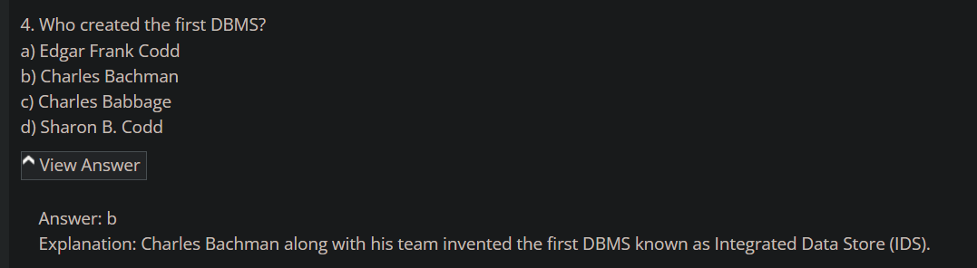

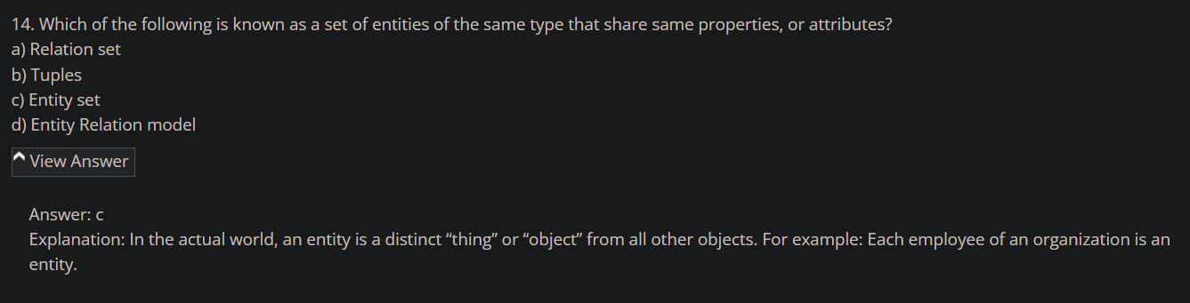

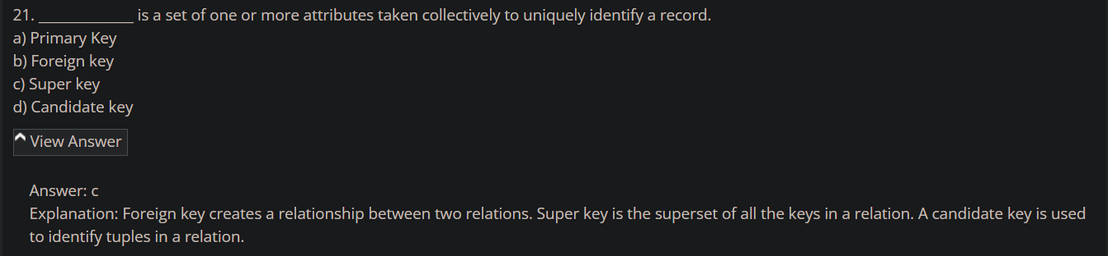

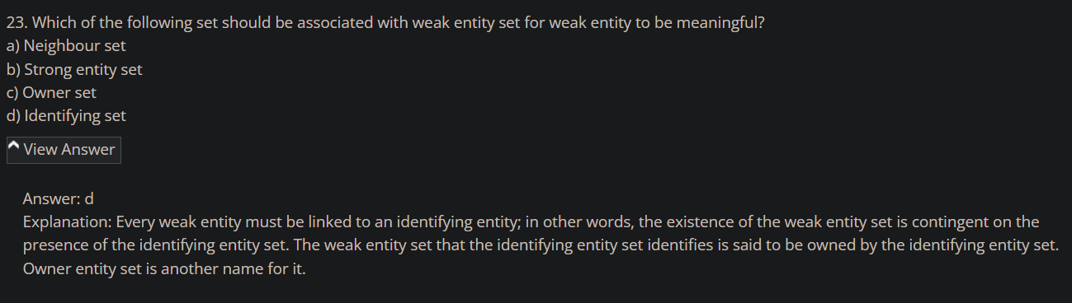

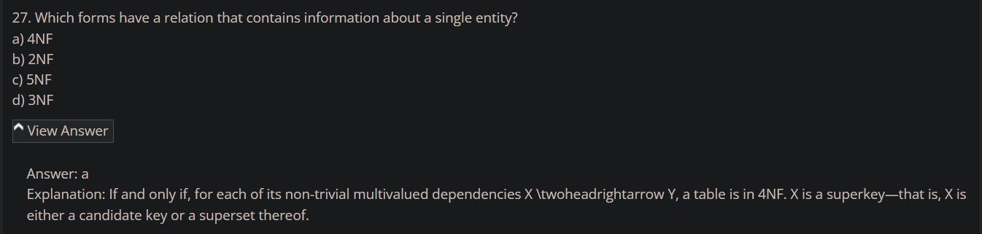

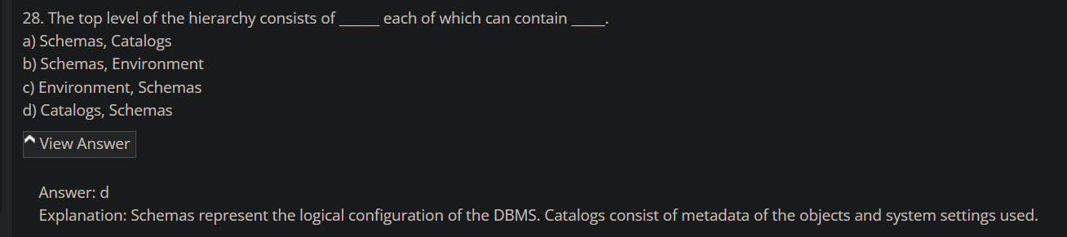

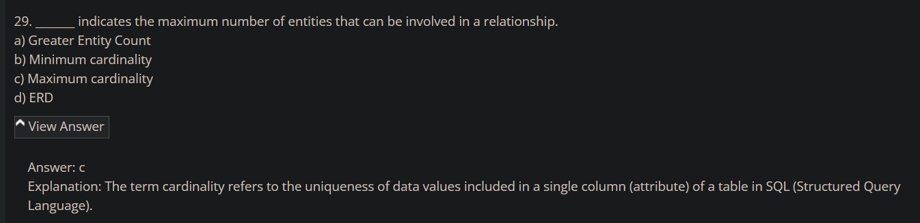

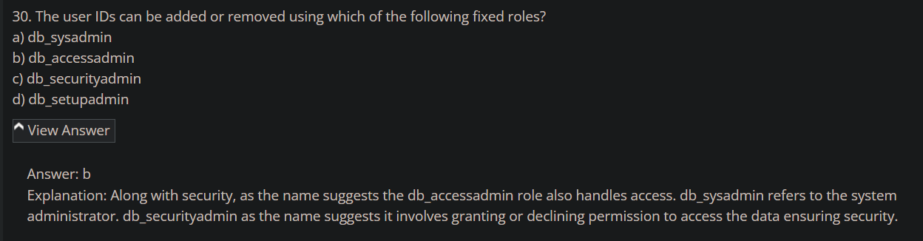

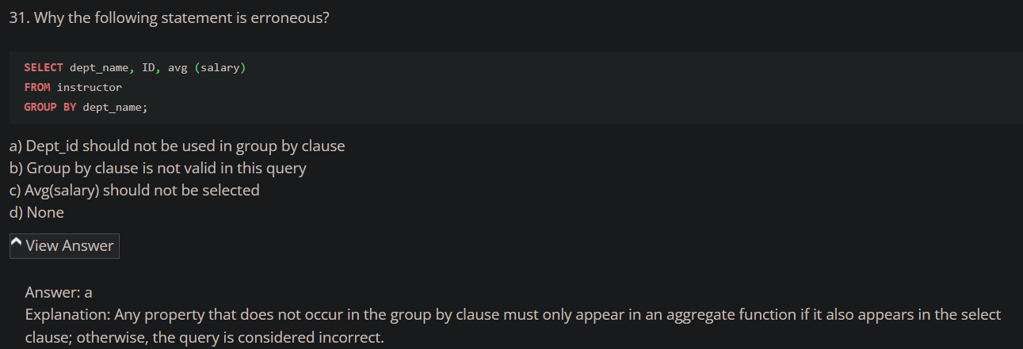

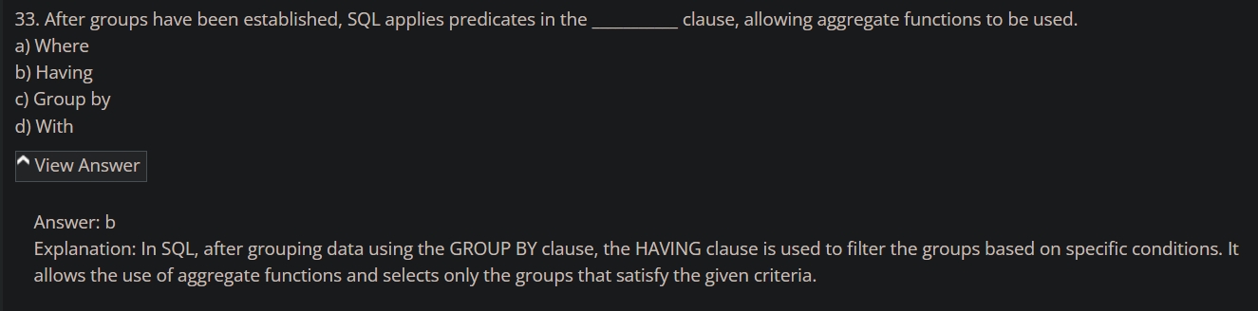

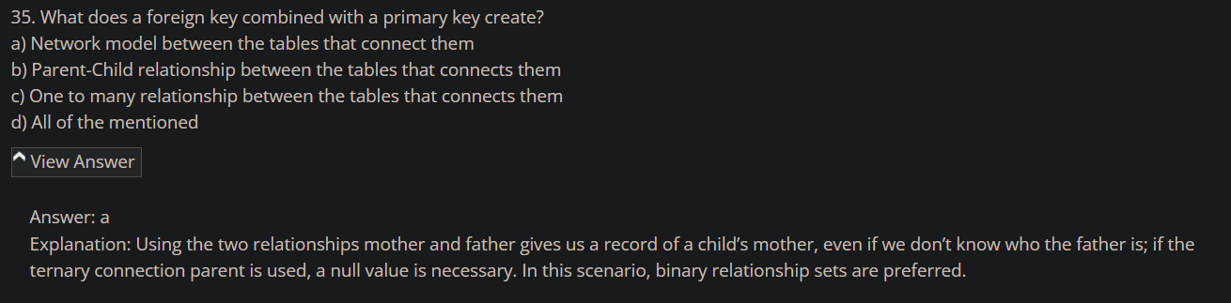

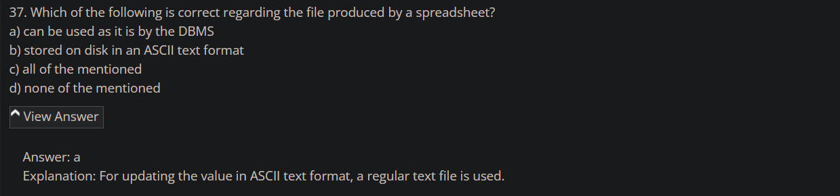

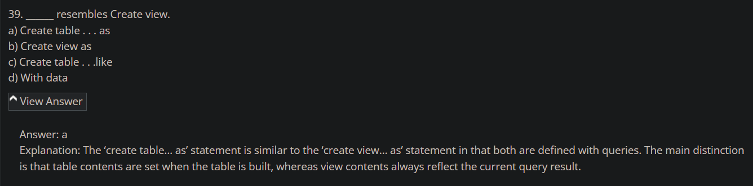

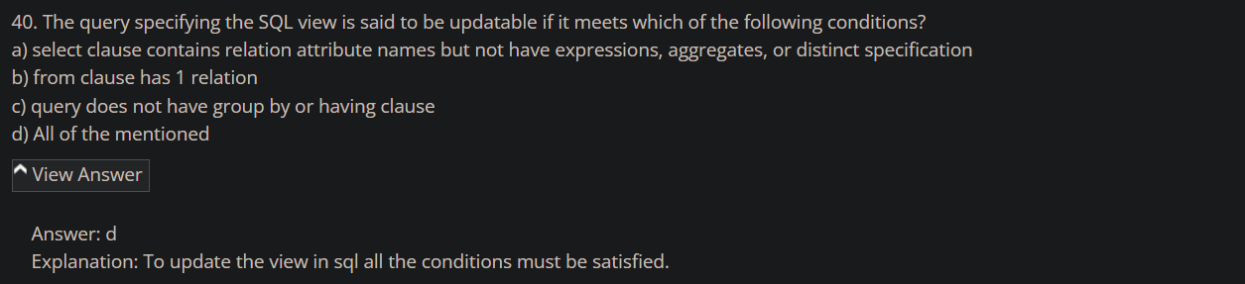

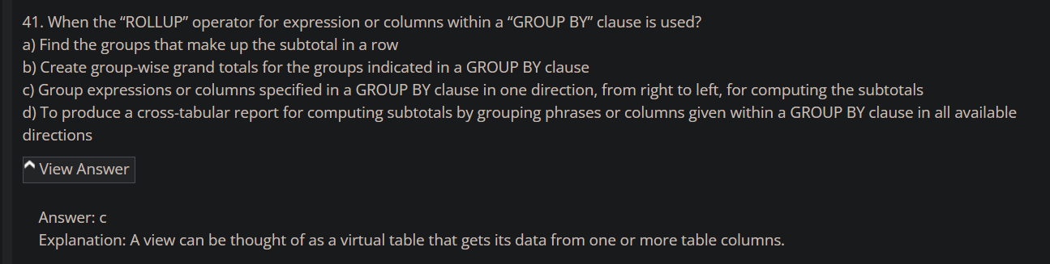

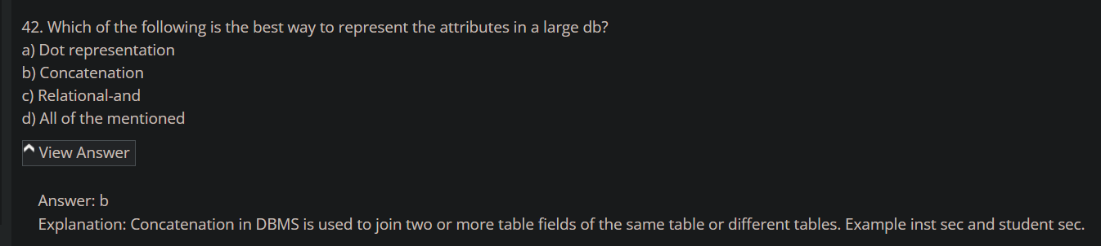

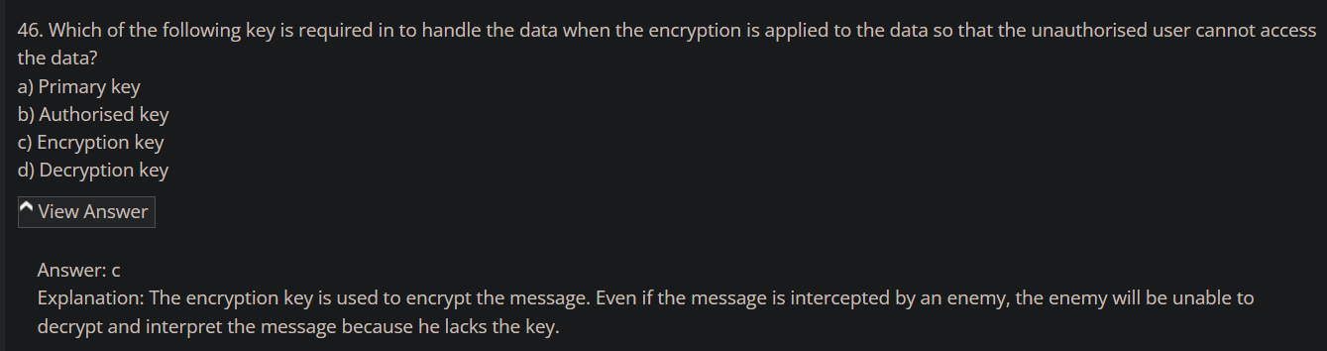

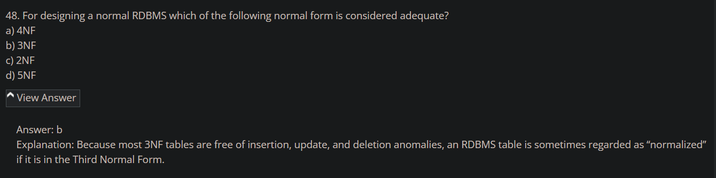

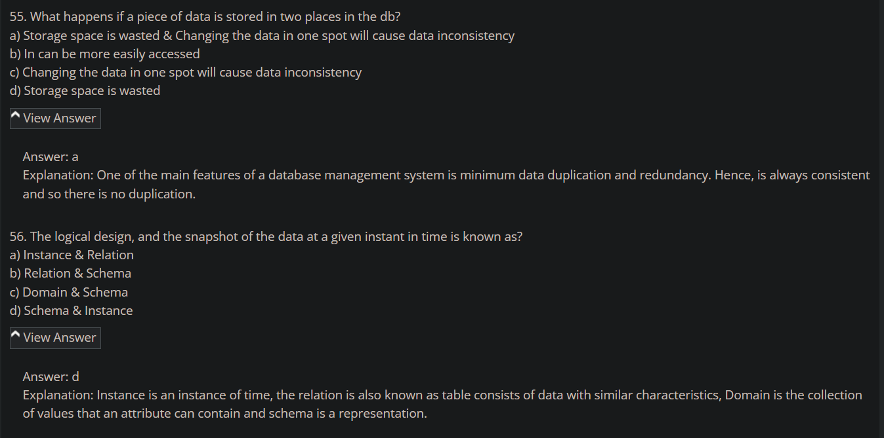

1. <https://www.sanfoundry.com/database-mcqs-relational-database-schema/>

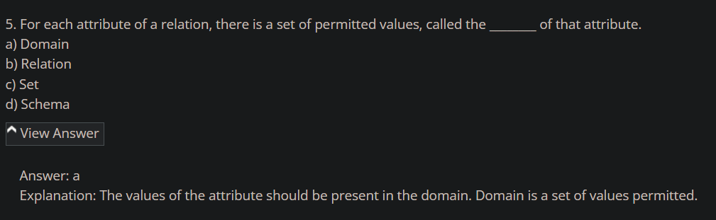

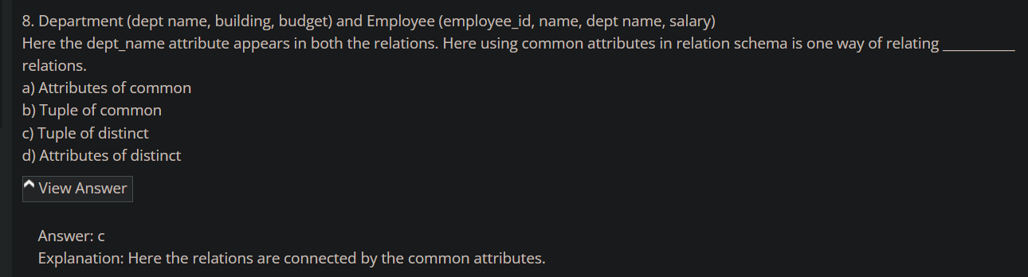

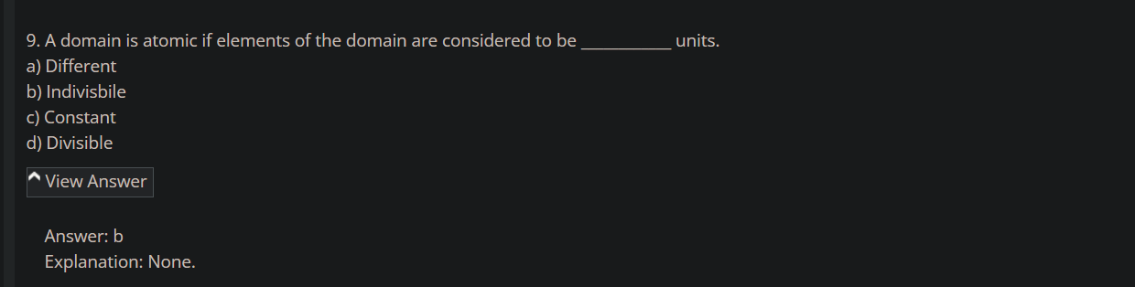

1. <https://www.sanfoundry.com/database-mcqs-keys/>

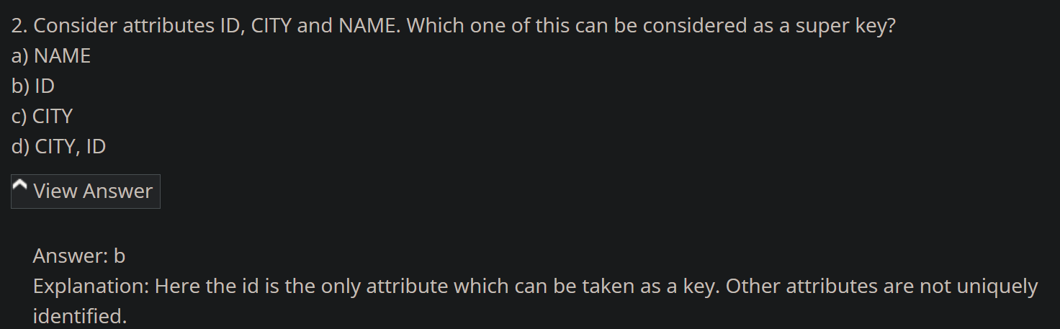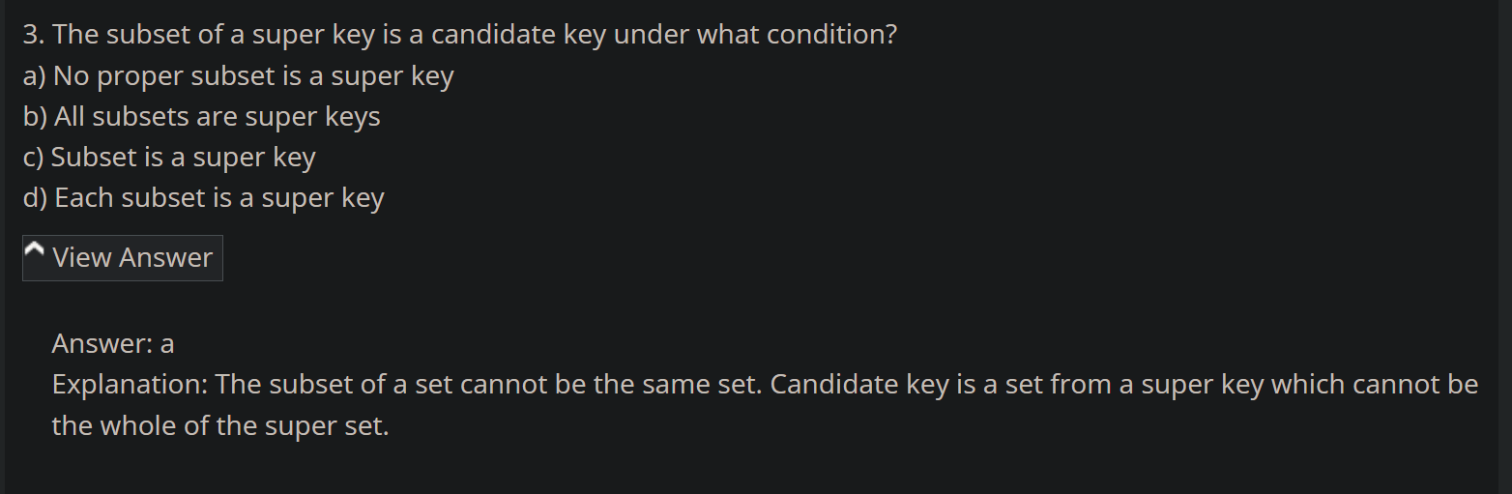

Relation =~= Table

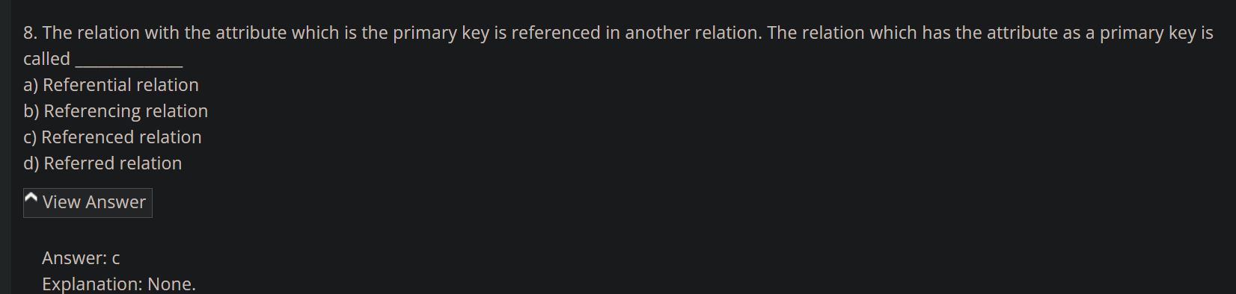

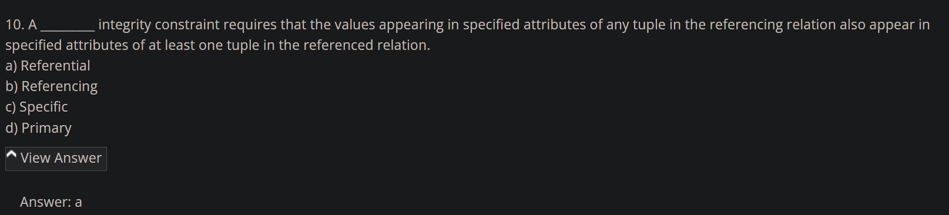

1. https://www.sanfoundry.com/database-questions-answers-mcqs/

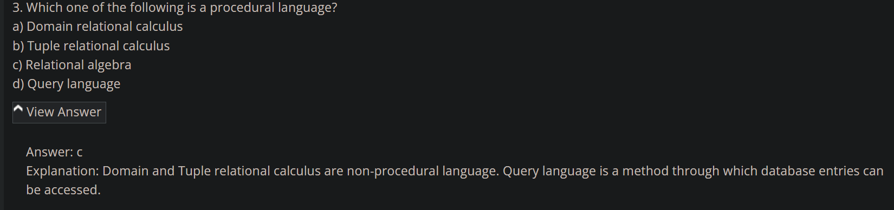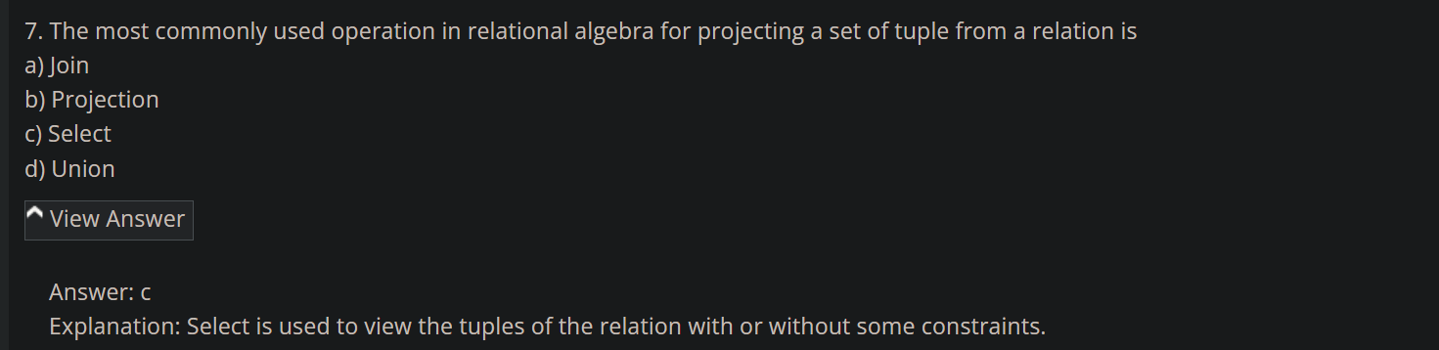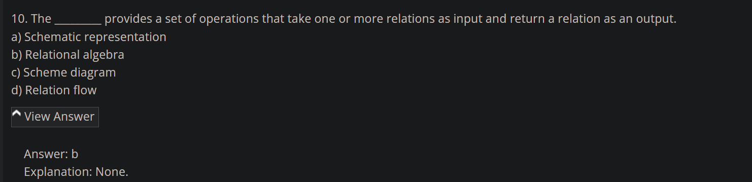

1. <https://www.sanfoundry.com/database-mcqs-sql-basics-definitions/>

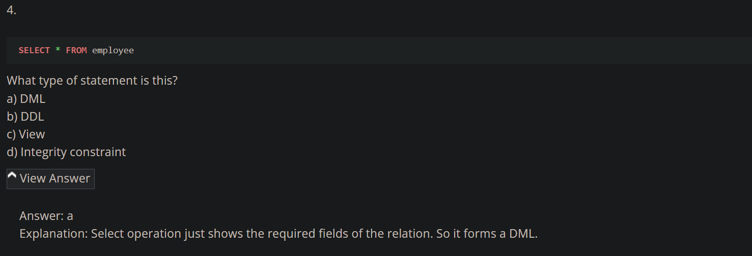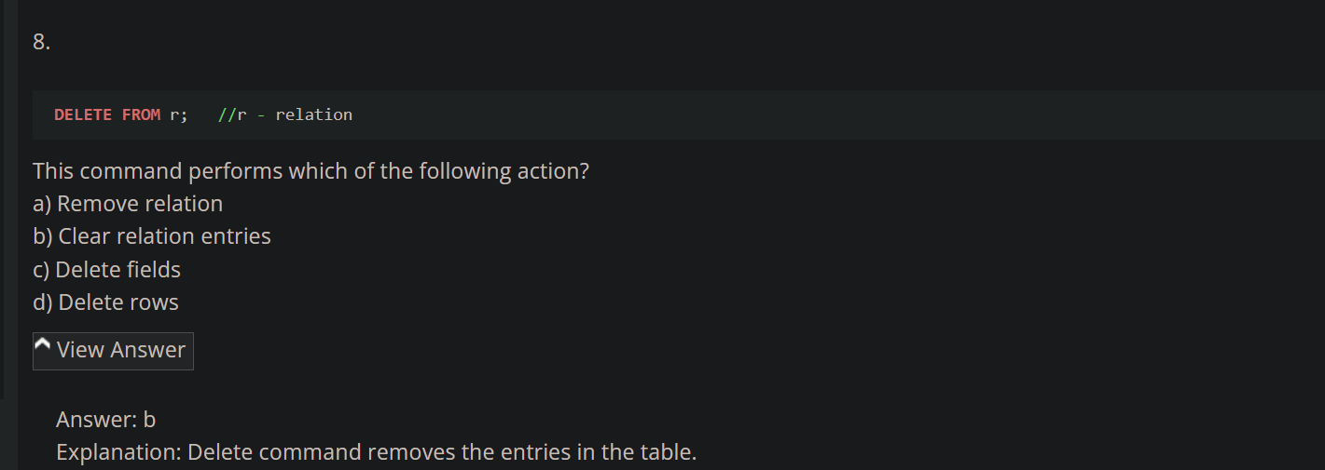

1. <https://www.sanfoundry.com/rdbms-questions-answers-sql-data-definition/>

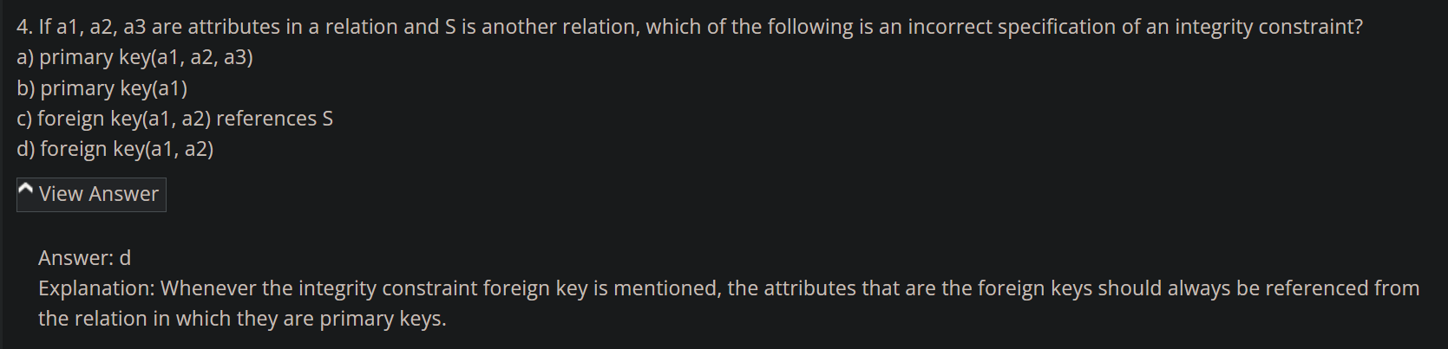

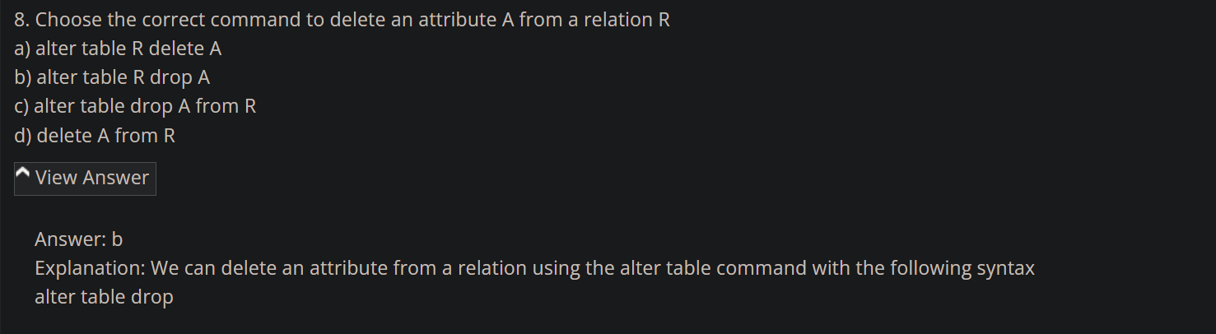

1. <https://www.interviewbit.com/rdbms-mcq/>

